https://indsec-site-1.vercel.app/

- Mandatory Disclosure either in the form of Pop Up / Clickable at Prominent Place on Home Page / Footer (It can-not be PDF / Clickable Link where it opens in another web link)

A.
ATTENTION INVESTORS

- Prevent Unauthorised transactions in your account --> Update your mobile numbers/email IDs with your stock brokers. Receive information of your transactions directly from Exchange on your mobile/email at the end of the day
- "KYC is one time exercise while dealing in securities markets - once KYC is done through a SEBI registered intermediary (broker, DP, Mutual Fund etc.), you need not undergo the same process again when you approach another intermediary."
- Stock Brokers can accept securities as margin from clients only by way of pledge in the depository system w.e.f. September 1, 2020.
- Update your Mobile Number & Email ID with your Stock Broker / Depository Participant and receive OTP directly from depository on your Email ID and/or Mobile Number to create pledge.
- Check your Securities /MF/ Bonds in the consolidated account statement issued by NSDL/CDSL every month.
- Pay 20% upfront margin of the transaction value to trade in Cash Market Segment.
- Investors may please refer to the Exchange's Frequently Asked Questions (FAQs) issued vide circular reference NSE/INSP/45191 dated July 31, 2020 and NSE/INSP/45534 dated August 31, 2020 and other guidelines issued from time to time in this regard.

.......... ISSUED IN THE INTEREST OF INVESTORS ..........

B.
Advisory for investors

"Attention Investors!
Beware of fixed/guaranteed/regular returns/ capital protection schemes. Brokers or their authorized persons or any of their associates are not authorized to offer fixed/guaranteed/regular returns/ capital protection on your investment or authorized to enter into any loan agreement with you to pay interest on the funds offered by you. Please note that in case of default of a member claim for funds or securities given to the broker under any arrangement/ agreement of indicative return will not be accepted by the relevant Committee of the Exchange as per the approved norms.

Do not keep funds idle with the Stock Broker. Please note that your stock broker has to return the credit balance lying with them, within three working days in case you have not done any transaction within last 30 calendar days. Please note that in case of default of a Member, claim for funds and securities, without any transaction on the exchange will not be accepted by the relevant Committee of the Exchange as per the approved norms.

Check the frequency of accounts settlement opted for. If you have opted for running account, please ensure that your broker settles your account and, in any case, not later than once in 90 days (or 30 days if you have opted for 30 days settlement). In case of declaration of trading member as defaulter, the claims of clients against such defaulter member would be subject to norms for eligibility of claims for compensation from IPF to the clients of the defaulter member. These norms are available on Exchange website of BSE & NSE at following link respectively:
https://www.bseindia.com/static/investors/claim-against-defaulter
https://www.nseindia.com/invest/about-defaulter-section

Brokers are not permitted to accept transfer of securities as margin. Securities offered as margin/ collateral MUST remain in the account of the client and can be pledged to the broker only by way of 'margin pledge', created in the Depository system. Clients are not permitted to place any securities with the broker or associate of the broker or authorized person of the broker for any reason. Broker can take securities belonging to clients only for settlement of securities sold by the client.

Always keep your contact details viz. Mobile number/Email ID updated with the stock broker. Email and mobile number is mandatory and you must provide the same to your broker for updation in Exchange records. You must immediately take up the matter with Stock Broker/Exchange if you are not receiving the messages from Exchange/Depositories regularly.

Don't ignore any emails/SMSs received from the Exchange for trades done by you. Verify the same with the Contract notes/Statement of accounts received from your broker and report discrepancy, if any, to your broker in writing immediately and if the Stock Broker does not respond, please take this up with the Exchange/Depositories forthwith.

Check messages sent by Exchanges on a weekly basis regarding funds and securities balances reported by the trading member, compare it with the weekly statement of account sent by broker and immediately raise a concern to the exchange if you notice a discrepancy.

Please do not transfer funds, for the purposes of trading to anyone, including an authorized person or an associate of the broker, other than a SEBI registered Stock broker."

C.
RISK DISCLOSURES ON DERIVATIVES
- 9 out of 10 individual traders in equity Futures and Options Segment, incurred net losses.
- On an average, loss makers registered net trading loss close to ₹ 50,000.
- Over and above the net trading losses incurred, loss makers expended an additional 28% of net trading losses as transaction costs.
- Those making net trading profits, incurred between 15% to 50% of such profits as transaction cost.

Source:
SEBI study dated January 25, 2023 on “Analysis of Profit and Loss of Individual Traders dealing in equity Futures and Options (F&O) Segment”, wherein Aggregate Level findings are based on annual Profit/Loss incurred by individual traders in equity F&O during FY 2021-22.

- Client List
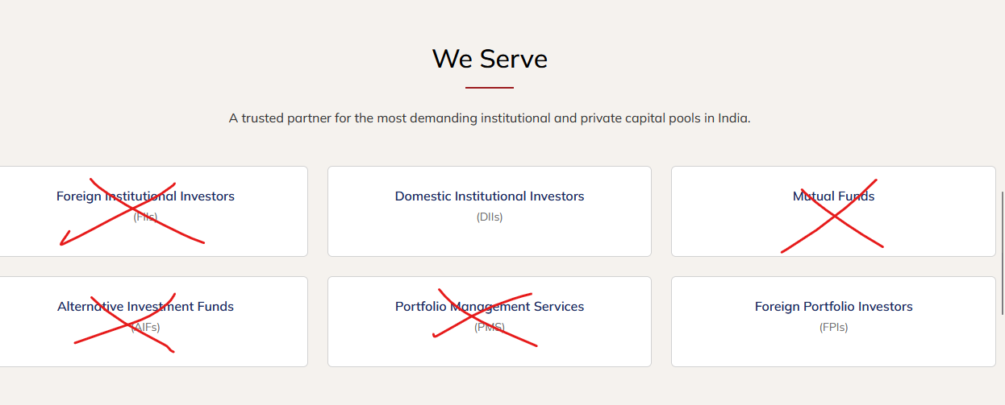

Keep only 2 Categories and Add List of Clients in Pop Up for the respective Categories – List will be shared separately (there will be periodic addition / deletion)

- Investor Relations Tab (https://indsec-site-1.vercel.app/investor-relations#disclosures) can be renamed to Disclosures / Downloads / Communication

- Mandatory Disclosures to be added from following source (including files)
- Client Registration Documents https://www.indsec.co.in/client-registration-document
- Investor Charter & Complaints - https://www.indsec.co.in/investors.aspx

https://indsec-site-1.vercel.app/investor-relations#disclosures
Investor Charter and Compliant can be presented as under with link to respective PDFs (Complaint file to be updated every month with latest month data):
Investor Charter | Investor Complaint
- Stock Broker  - Depository Participant  - PMS  - Research Analyst | - Stock Broker  - Depository Participant  - PMS

- Investor Mobile Application by Depositories - https://www.indsec.co.in/investor-mobile-application-by-depositories
- Guidance to view KRA Status and Steps to Update - https://www.indsec.co.in/kra-status.aspx
- https://www.indsec.co.in/investor-awareness-and-education.aspx
- Client Bank Account Details - https://www.indsec.co.in/client-bank-account
- Research Disclosure - https://www.indsec.co.in/researchdisclaimeranddisclosures
- e-Voting Facility Provided by Listed Entities - https://indsec.co.in/evoting/evoting.html
- Corporate Disclosures:
- Notices
- Annual Returns
- CSR
- Policies
(PDFs to be updated under each tab – reference of existing website given below)

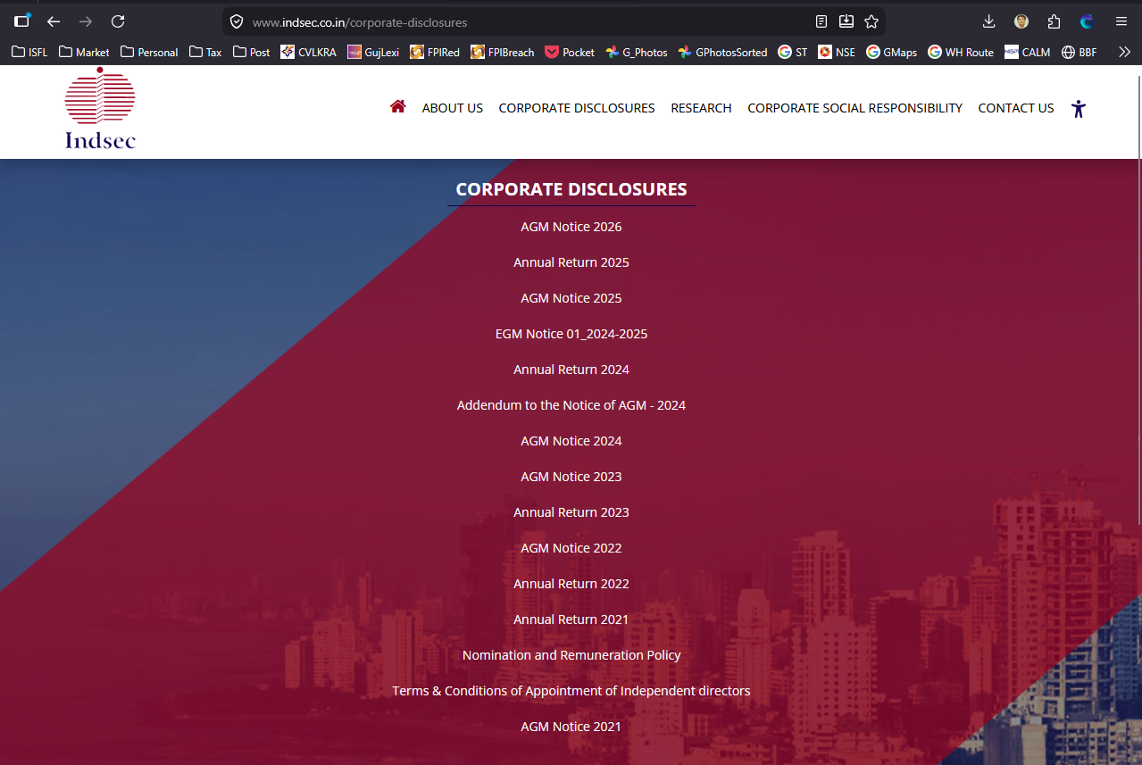
- PDF file to be uploaded as under:
  - Operation of accounts in case of an incapacitated investor - https://www.indsec.co.in/pdf/Common%20SOP%20for%20operation%20of%20accounts%20in%20case%20of%20an%20incapacitated%20investor%20Applicable%20to%20Depositories%20and%20Mutual%20Funds.pdf
  - PMLA Policy - https://www.indsec.co.in/pdf/20240508%20-%20Anti%20Money%20Laundering.pdf
  - PMS Disclosure Document - https://www.indsec.co.in/pdf/Indsec%20Disclosure%20Document%20-%20Website.pdf
  - Procedure for Opening Trading / Demat Account (Offline Process Only) - https://www.indsec.co.in/contact-us (PDF will be provided)
  - Procedure for Filing a Complaint with us - https://www.indsec.co.in/contact-us(PDF will be provided)
  - Escalation Matrix - https://www.indsec.co.in/contact-us (PDF will be provided)

- Please remove following from https://indsec-site-1.vercel.app/investor-relations#disclosures as its covered under different links
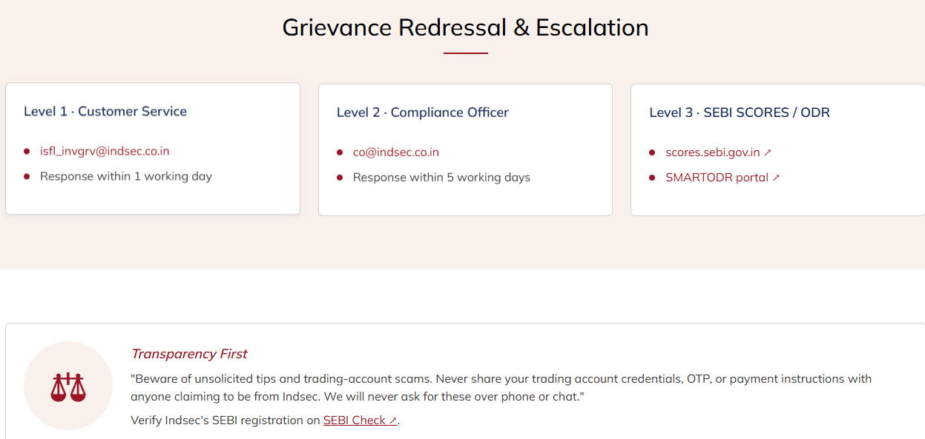

- Important Links / can be given for following (Link to Important Link Page also to be provided in Footer):
- Investor Complaint / Grievance Redressal (Please quote your Service Ticket / Complaint Ref No. while raising your complaint at SEBI SCORES / Depository / Exchange portal)
- SMART ODR - Link to be given https://smartodr.in/login
- SEBI Scores - Link to be given https://scores.sebi.gov.in/
- NSDL – Link to be given https://nsdl.co.in/nsdlnews/investors.php
- NSE – Link to be given https://investorhelpline.nseindia.com/NICEPLUS/
- BSE - Link to be given https://bsecrs.bseindia.com/ecomplaint/frmInvestorHome.aspx
- View Client Collateral Details – Link to be given https://investorhelpline.nseclearing.in/ClientCollateral/welcomeCLUser
- BSE – Link to be given https://www.bseindia.com
- NSE – Link to be given https://www.nseindia.com
- NSDL – Link to be given https://nsdl.co.in
- SEBI – Link to be given https://www.sebi.gov.in

- Footer needs to be updated as under
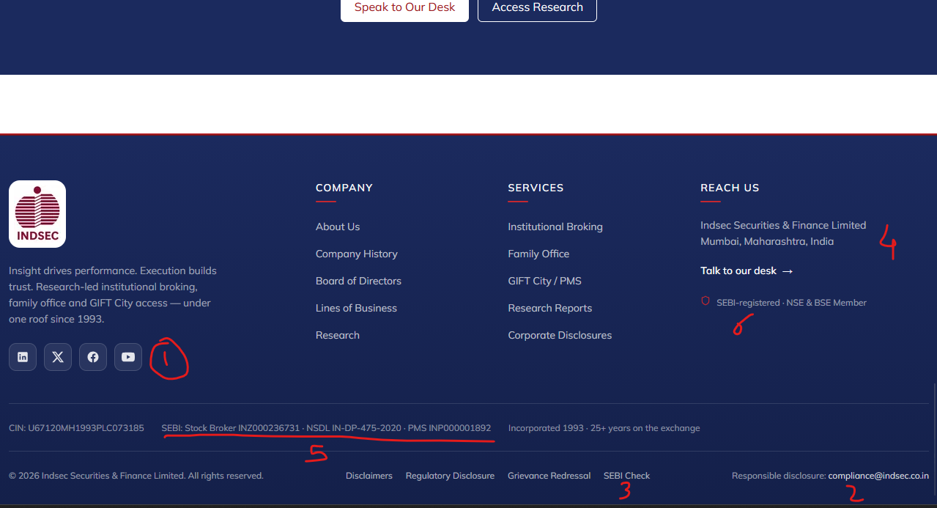
- Only Linked in Link to be given - https://www.linkedin.com/company/indsec-securities-and-finance-ltd/ (Remove X / FB / YT)
- No need for this Tab – any website related queries can be addressed on isfl@indsec.co.in
- SEBI Check is part of Disclosures (under Client Bank Accounts) – can be removed
- Reach Us can redirect to Contact Tab (Clickable)
- Following data can be added / updated
CIN : U67120MH1993PLC073185 | PAN : AAACI1958G | GSTIN : 27AAACI1958G1ZL
SEBI Registration Nos. :- BSE / NSE / MCX-SX – INZ000236731 | NSDL – IN-DP-475-2020 | PMS – INP000001892
AMFI Registration No. – ARN 9194
Email Id for Investor Grievances - isfl_invgrv@indsec.co.in
- “SEBI Registered…” Not required – can be removed
- Following matter should be placed in Footer
Filing complaints on SEBI SCORES is Easy & quick: a. Register on SCORES portal. b. Mandatory details for filing complaints on SCORES: Name, PAN, Address, Mobile Number, E-mail ID. c. Benefits: i. Effective communication ii. Speedy redressal of the grievances.

- Research reports section on https://indsec-site-1.vercel.app/research#reports needs to undergo change (will communicate separately)

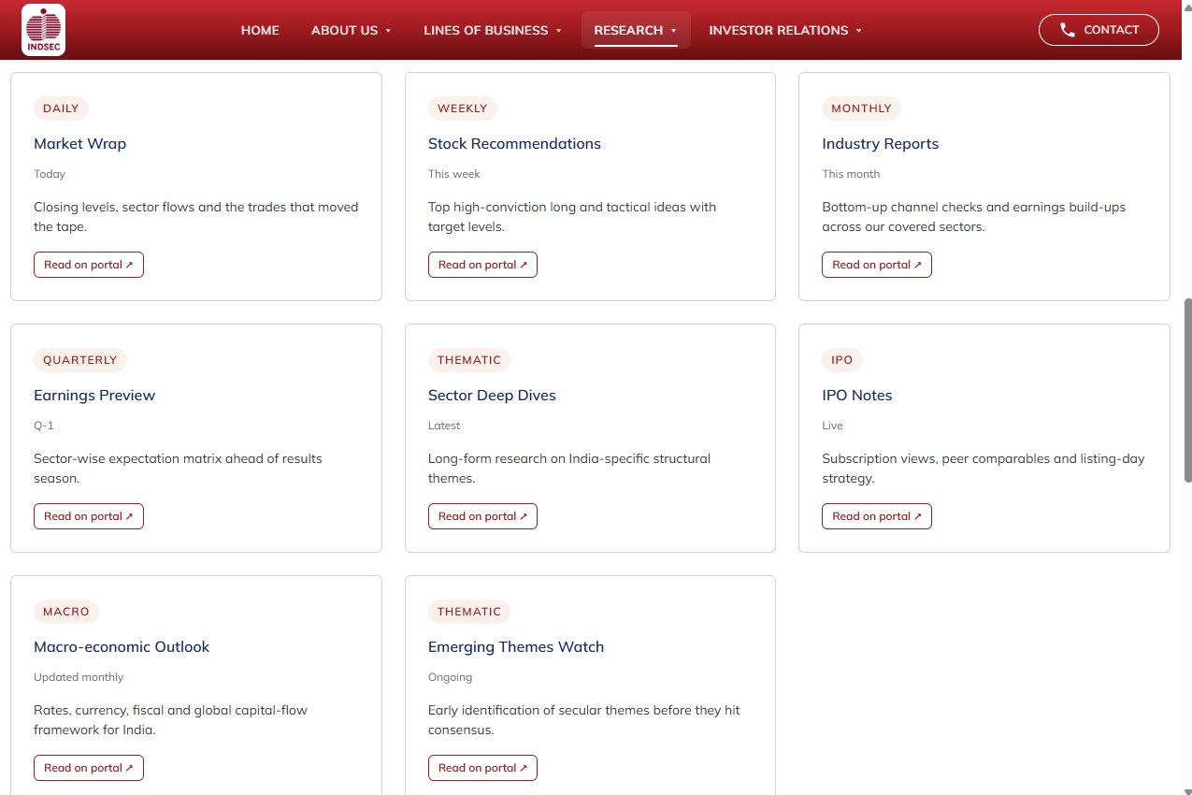f

